Cloud Data Centres – Lab 2

Hello MiniKube:

I loaded the dashboard through terminal and now have it running locally:

1. ***I then created a deployment using this command:*** kubectl create deployment hello-node --image=registry.k8s.io/e2e-test-images/agnhost:2.39 -- /agnhost netexec --http-port=8080

Here you can see the deployment and the pod through my terminal

Then I exposed it to the internet



I then ran the following command to get it working in the browser:

Deploy An App:

I created the bootcamp deployment through terminal

I then hosted the proxy

Then I got the pod name and stored it:

Explore Your App:

I got the pod name here:

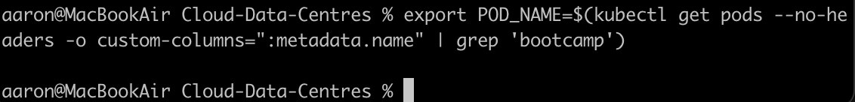

Here is the output of our application:

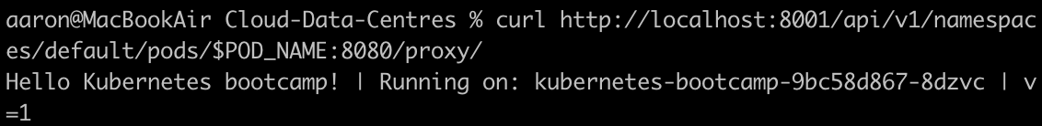

These are the environment variables

Now I am starting a bash session:

Now we can run a node js application

Expose your app publicly:

Here I am just listing the current pods

Here I’m exposing the bootcamp to external traffic



We now have a Kubernetes bootcamp service

This is the Kubernetes bootcamp description

Now I’m creating a variable for the node port



Then I deployed it



This is the deployment description

Here I am getting the pod name and labelling it

Now I can query the pod using the new label

Now I can use the label to delete as well

Scale Your App:

We have the bootcamp deployment and replica here

We now have 4 replicas of the bootcamp

Each node now has a different IP address

Here I am getting the node port

Now I have it running

Now we can scale deployments back down

Update Your App:

Here I am updating the image for the bootcamp

As can be seen it is running the new image



Here I’m setting a new image

One of the images didn’t update as expected so we rolled it back

Then finally cleaning up and deleting the bootcamp

